The 2018 National Conference of Bankruptcy Clerks
Bronze Membership Award
Presented to
District of Louisiana Western

In recognition of achieving court membership between 25% and 49%
in the National Conference of Bankruptcy Clerks

Presented by the National Conference of Bankruptcy Clerk’s
On This 15th day of August 2018
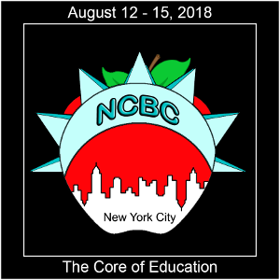
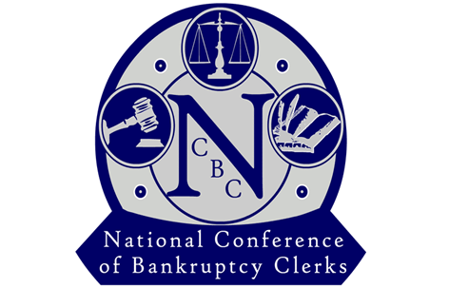

_______________________________________
Regina Thomas, President

