The 2018 National Conference of Bankruptcy Clerks
Silver Membership Award
Presented to
District of New Hampshire

In recognition of achieving court membership between 50% and 74%
in the National Conference of Bankruptcy Clerks

Presented by the National Conference of Bankruptcy Clerk’s
On This 15th day of August 2018
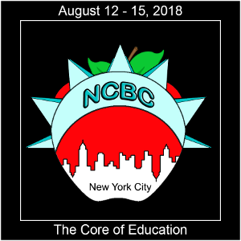
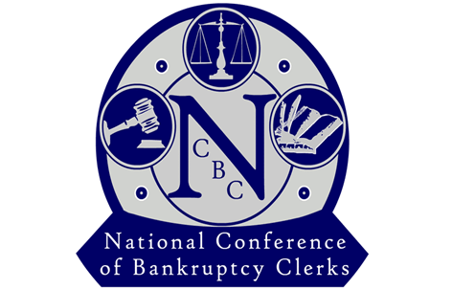

_______________________________________
Regina Thomas, President

