The 2018 National Conference of Bankruptcy Clerks
Gold Membership Award
Presented to
District of Washington DC

In recognition of achieving court membership between 75% and 100%
in the National Conference of Bankruptcy Clerks

Presented by the National Conference of Bankruptcy Clerk’s
On This 15th day of August 2018

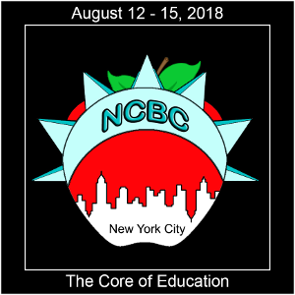
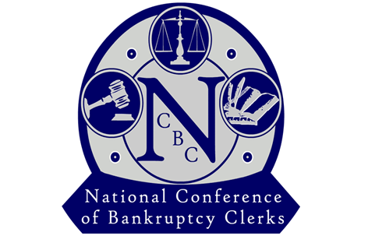

_______________________________________
Regina Thomas, President

