The 2017 National Conference of Bankruptcy Clerks
Silver Membership Award
Presented to
Middle District of Tennessee

In recognition of achieving court membership between 50% and 74%
in the National Conference of Bankruptcy Clerks

Presented by the National Conference of Bankruptcy Clerk’s
On This 20th day of July 2017
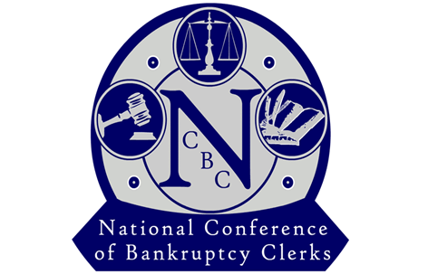

_______________________________________
Regina Thomas, President

