The 2017 National Conference of Bankruptcy Clerks
Gold Membership Award
Presented to
Middle District of Louisiana

In recognition of achieving court membership between 75% and 100%
in the National Conference of Bankruptcy Clerks

Presented by the National Conference of Bankruptcy Clerk’s
On This 20th day of July 2017
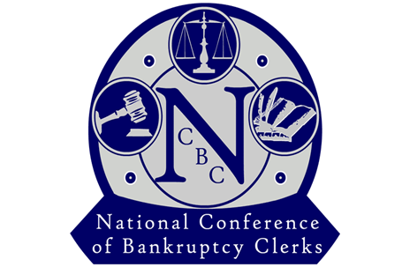

_______________________________________
Regina Thomas, President

